Data Migration

🌟 Definition
# Source: AI Source: Provided by: [Data Path: Persons Table -> ID Column: 1, Name_En Column: Motasem Essam] -> From: [ChatGPT] on [6/7/2026]
Data Migration is the process of moving, copying, transforming, or transferring data from one location, database, system, or format to another.
Unlike Schema Migration, which changes the database structure, Data Migration focuses on the actual records (data).

🎯 Purpose
# Source: AI Source: Provided by: [Data Path: Persons Table -> ID Column: 1, Name_En Column: Motasem Essam] -> From: [ChatGPT] on [6/7/2026]
Data migration is performed to:
- Move data to a new database
- Upgrade systems
- Consolidate databases
- Archive old records
- Move data to the cloud
- Change data formats
- Improve data quality

🧠 Simple Definition
# Source: AI Source: Provided by: [Data Path: Persons Table -> ID Column: 1, Name_En Column: Motasem Essam] -> From: [ChatGPT] on [6/7/2026]
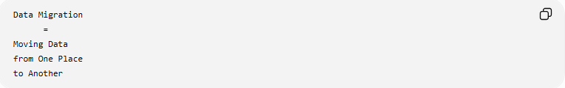
Data Migration
=
Moving Data
from One Place
to Another

📚 What Gets Migrated?
# Source: AI Source: Provided by: [Data Path: Persons Table -> ID Column: 1, Name_En Column: Motasem Essam] -> From: [ChatGPT] on [6/7/2026]
Data migration can move:
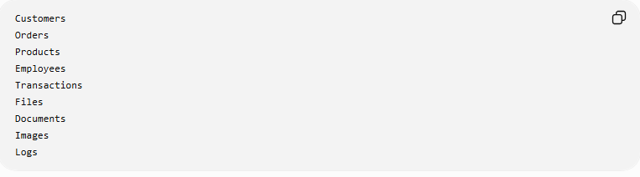
Customers
Orders
Products
Employees
Transactions
Files
Documents
Images
Logs

🔍 Types of Data Migration

1️⃣ Database-to-Database Migration
# Source: AI Source: Provided by: [Data Path: Persons Table -> ID Column: 1, Name_En Column: Motasem Essam] -> From: [ChatGPT] on [6/7/2026]
Move data between databases.
Example
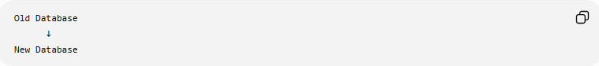
Old Database
↓
New Database

SQL Example
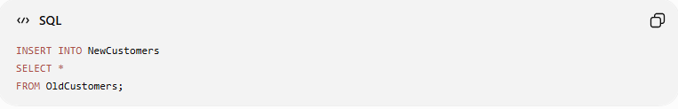
INSERT INTO NewCustomers
SELECT *
FROM OldCustomers;

Result:
Customer Records Copied

2️⃣ System-to-System Migration
# Source: AI Source: Provided by: [Data Path: Persons Table -> ID Column: 1, Name_En Column: Motasem Essam] -> From: [ChatGPT] on [6/7/2026]
Move data between applications.
Example
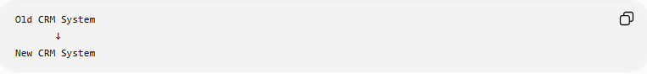
Old CRM System
↓
New CRM System

Data transferred:
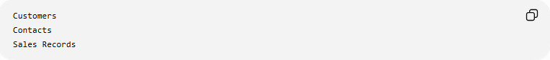
Customers
Contacts
Sales Records

3️⃣ Cloud Data Migration
# Source: AI Source: Provided by: [Data Path: Persons Table -> ID Column: 1, Name_En Column: Motasem Essam] -> From: [ChatGPT] on [6/7/2026]
Move data to the cloud.
Example
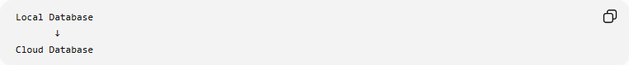
Local Database
↓
Cloud Database

Examples:
- Amazon Web Services RDS
- Microsoft SQL Database
- Google Cloud SQL

4️⃣ Storage Migration
# Source: AI Source: Provided by: [Data Path: Persons Table -> ID Column: 1, Name_En Column: Motasem Essam] -> From: [ChatGPT] on [6/7/2026]
Move data between storage systems.
Example
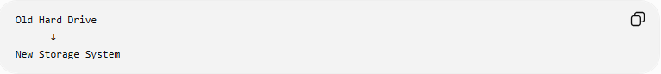
Old Hard Drive
↓
New Storage System

Data moved:
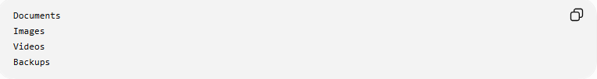
Documents
Images
Videos
Backups

5️⃣ Data Transformation Migration
# Source: AI Source: Provided by: [Data Path: Persons Table -> ID Column: 1, Name_En Column: Motasem Essam] -> From: [ChatGPT] on [6/7/2026]
Move data while changing its format.
Before
FirstName
LastName

After
FullName

Example:
Ali
Hassan
becomes:
Ali Hassan

🛠️ Common Data Migration Operations
# Source: AI Source: Provided by: [Data Path: Persons Table -> ID Column: 1, Name_En Column: Motasem Essam] -> From: [ChatGPT] on [6/7/2026]
Copy Data
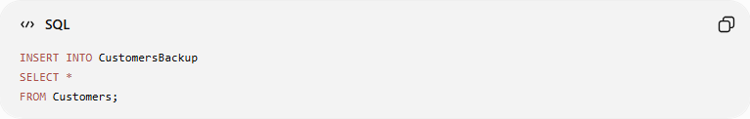
INSERT INTO CustomersBackup
SELECT *
FROM Customers;

Move Data
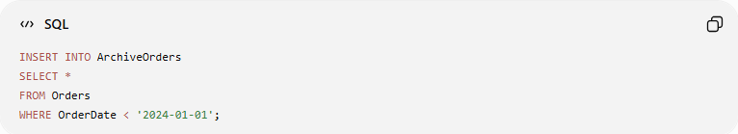
INSERT INTO ArchiveOrders
SELECT *
FROM Orders
WHERE OrderDate < '2024-01-01';

Then remove old records:
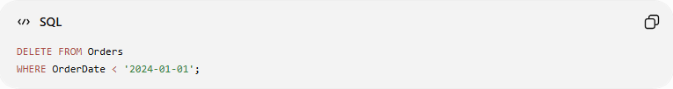
DELETE FROM Orders
WHERE OrderDate < '2024-01-01';

Transform Data
Before
Status = 1
Status = 0

After
Active
Inactive

SQL Example:
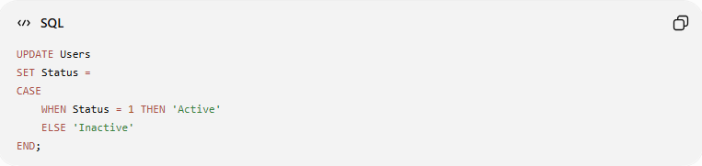
UPDATE Users
SET Status =
CASE
WHEN Status = 1 THEN 'Active'
ELSE 'Inactive'
END;

📊 ETL Process
# Source: AI Source: Provided by: [Data Path: Persons Table -> ID Column: 1, Name_En Column: Motasem Essam] -> From: [ChatGPT] on [6/7/2026]
Most large data migrations follow the ETL process.
E — Extract
Read data from source.
Old Database
↓
T — Transform
Clean and convert data.
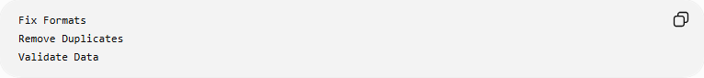
Fix Formats
Remove Duplicates
Validate Data
↓
L — Load
Insert into destination.
New Database

Process:
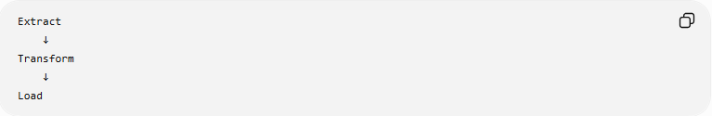
Extract
↓
Transform
↓
Load

🌍 Real-World Example
# Source: AI Source: Provided by: [Data Path: Persons Table -> ID Column: 1, Name_En Column: Motasem Essam] -> From: [ChatGPT] on [6/7/2026]
Before Migration
Old Customers Table
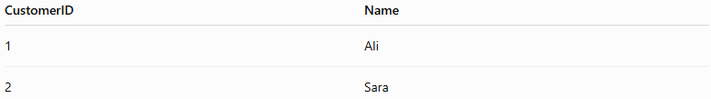
CustomerID | Name
1 | Ali
2 | Sara

New Customers Table
(empty)

Migration
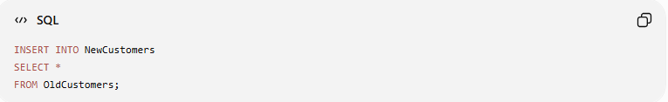
INSERT INTO NewCustomers
SELECT *
FROM OldCustomers;

Result
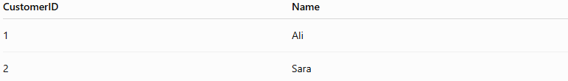
CustomerID | Name
1 | Ali
2 | Sara
Data successfully moved.

🔄 Data Migration Lifecycle
# Source: AI Source: Provided by: [Data Path: Persons Table -> ID Column: 1, Name_En Column: Motasem Essam] -> From: [ChatGPT] on [6/7/2026]
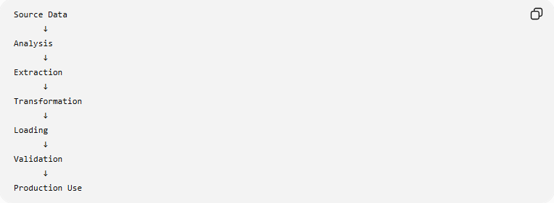
Source Data
↓
Analysis
↓
Extraction
↓
Transformation
↓
Loading
↓
Validation
↓
Production Use

⚠️ Common Challenges
# Source: AI Source: Provided by: [Data Path: Persons Table -> ID Column: 1, Name_En Column: Motasem Essam] -> From: [ChatGPT] on [6/7/2026]
Possible issues:
- Missing records
- Duplicate data
- Invalid formats
- Corrupted data
- Slow migration
- Downtime

📚 Example: Data Cleaning During Migration
# Source: AI Source: Provided by: [Data Path: Persons Table -> ID Column: 1, Name_En Column: Motasem Essam] -> From: [ChatGPT] on [6/7/2026]
Source Data
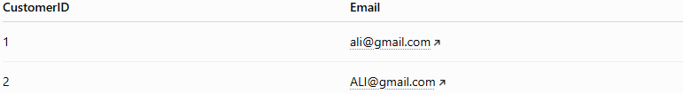
CustomerID | Email
1 | ali@gmail.com
2 | ALI@gmail.com

Problem:
Duplicate Emails

During migration:
Convert to Lowercase
Remove Duplicates

Result:
Cleaner Data

📦 Data Migration vs Schema Migration
# Source: AI Source: Provided by: [Data Path: Persons Table -> ID Column: 1, Name_En Column: Motasem Essam] -> From: [ChatGPT] on [6/7/2026]
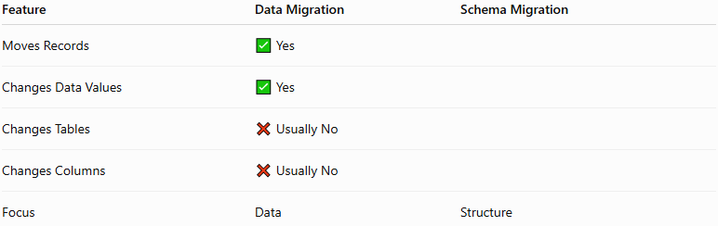
Feature | Data Migration | Schema Migration
Moves Records | ✅ Yes
Changes Data Values | ✅ Yes
Changes Tables | ❌ Usually No
Changes Columns | ❌ Usually No
Focus | Data | Structure

Data Migration Example
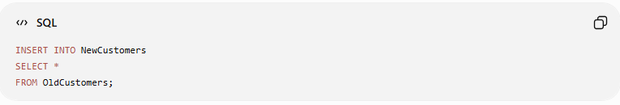
INSERT INTO NewCustomers
SELECT *
FROM OldCustomers;
Moves data.

Schema Migration Example
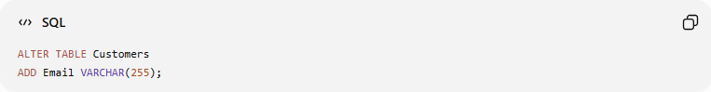
ALTER TABLE Customers
ADD Email VARCHAR(255);
Changes structure.

✅ Best Practices
# Source: AI Source: Provided by: [Data Path: Persons Table -> ID Column: 1, Name_En Column: Motasem Essam] -> From: [ChatGPT] on [6/7/2026]
Backup First
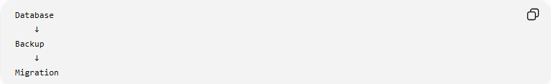
Database
↓
Backup
↓
Migration

Validate Data
Check:
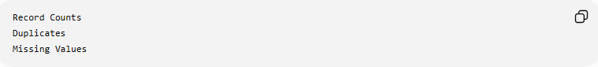
Record Counts
Duplicates
Missing Values

Test Before Production
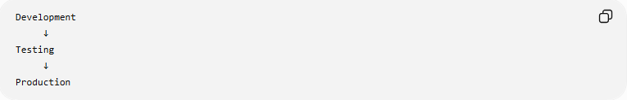
Development
↓
Testing
↓
Production

Migrate in Batches
Instead of:
10 Million Records At Once
Use:
100,000 Records Per Batch

🛠️ Common Data Migration Tools
# Source: AI Source: Provided by: [Data Path: Persons Table -> ID Column: 1, Name_En Column: Motasem Essam] -> From: [ChatGPT] on [6/7/2026]
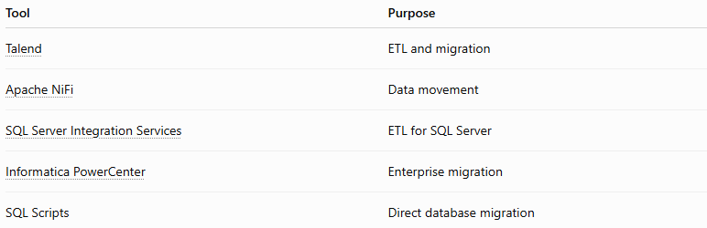
Tool | Purpose
Talend | ETL and migration
Apache NiFi | Data movement
SQL Server Integration Services | ETL for SQL Server
Informatica PowerCenter | Enterprise migration
SQL Scripts | Direct database migration

🧠 Simple Analogy
# Source: AI Source: Provided by: [Data Path: Persons Table -> ID Column: 1, Name_En Column: Motasem Essam] -> From: [ChatGPT] on [6/7/2026]
Think of moving to a new house.
Schema Migration
Build New House Structure

Data Migration
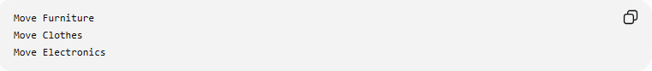
Move Furniture
Move Clothes
Move Electronics
The house structure stays the same, but the contents are transferred.
Similarly:
Schema Migration = Structure
Data Migration = Actual Data

🧭 Summary
# Source: AI Source: Provided by: [Data Path: Persons Table -> ID Column: 1, Name_En Column: Motasem Essam] -> From: [ChatGPT] on [6/7/2026]
Data Migration is a type of database migration that focuses on moving, copying, transforming, and loading actual data from one system, database, or storage location to another. Common activities include copying records, archiving data, data cleansing, format conversion, and ETL (Extract, Transform, Load) processes. Its primary goal is to ensure that data remains accurate, complete, and usable in the new environment.

